# **Name: Abdurrahman Qureshi**

# **Roll No: 242466**

Practical No: 8

Date Of Performance: 08/09/2025

Aim: To implement cryptographic has algorithms SHA-256 and SHA-512

SHA-256 CODE:

const crypto = require('crypto');

const plaintext = "Death is an old friend";

function sha256Hash(text) {

    return crypto.createHash('sha256').update(text).digest('hex');

}

const sha256Result = sha256Hash(plaintext);

console.log("Plaintext:", plaintext);

console.log("\nSHA-256 Hash:");

console.log(sha256Result);

OUPTUT:

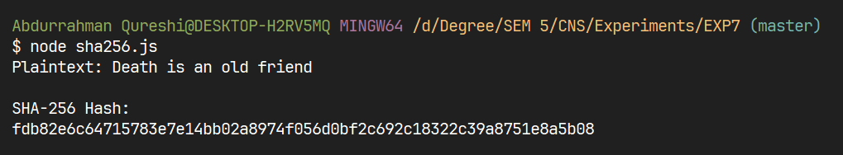

SHA-512 CODE:

const crypto = require('crypto');

const plaintext = "Death is an old friend";

function sha512Hash(text) {

    return crypto.createHash('sha512').update(text).digest('hex');

}

const sha512Result = sha512Hash(plaintext);

console.log("Plaintext:", plaintext);

console.log("\nSHA-512 Hash:");

console.log(sha512Result);

OUTPUT:

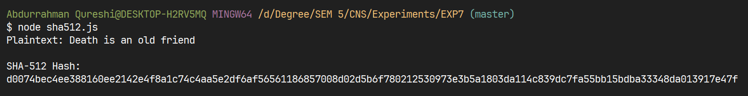

|  |  |  |  |  |  |
| --- | --- | --- | --- | --- | --- |
| Performance  (7M) | Journal  (3M) | Lab Ethics  (2M) | Attendance  (3M) | Total  (15M) | Faculty Signature |
|  |  |  |  |  |  |